**Restaurant Finder App**

**Design:**

View is app.component.html

It has a form which contains a text box and button. User must type the searchphrase in textbox and then click the Find button to submit to model

It also has 2 divs to display the successful search results and ‘Phrase not found’ on case of no match found

The text box is bound to a variable searchphrase in model

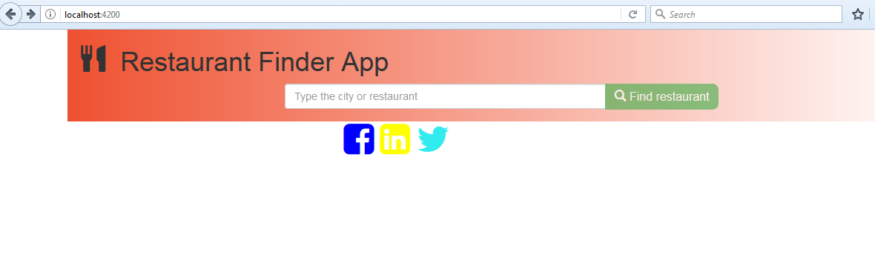

Fig 1: The initial screen

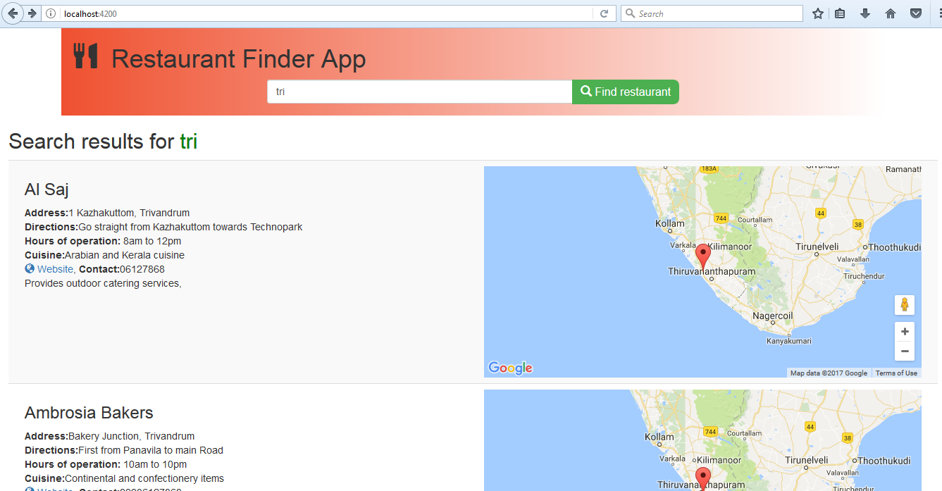

Fig 2: Results of search listed

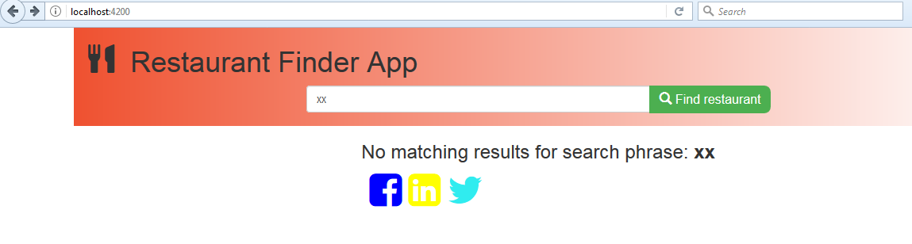

Fig3: No matches result

Model is app.component.ts

It has a listOfRestaurants which is an array of JSON objects. This is the original directory of all restaurants. The information stored include:

"name" – The name of restaurant

"address" – The address of restaurant

"directions" – The directions to reach there

"hoursOfOperation" – Timings of restaurant operation

"menu" – The general type of food served in the restaurant

"website" – The URL of the website

"contact" – Phone number

"catering" – Any catering details if applicable

"others"- Any other info

"lat"- Latitude of the geographical location

"long" – Longitude of the geographical location

There is an array called matchingRestaurants which is meant to hold all the objects which match the searchphrase entered by user

On click of Find button a function findMatch() is called which iterates through each object in listOfRestaurants and finds a match with any of the information listed above. If match is found, then push object to matchingRestaurants array.

In view, the matchingRestaurants list is displayed